LAB EXPERIMENT RECORD
SET 19: SURVEY RESPONSES ANALYSIS
Department | AIDS
Course Code / Course Name | DSA0601 / Data Handling and Visualization
Experiment | Data Visualization using R
Name | B. Pallavi
Register Number | 192424243
Date | 15 October 2026
Day | Tuesday

AIM
To analyze survey responses using bar charts, stacked bar charts, and a data table in R.
DATASET
Survey ID | Question 1 | Question 2 | Question 3
1 | A | B | C
2 | B | A | D
3 | C | A | B
PROGRAM 1: BAR CHART OF QUESTION 1 RESPONSES
R Code
responses <- c("A", "B", "C")
barplot(table(responses),
main="Question 1 Responses",
xlab="Answer",
ylab="Count",
col="skyblue")
Observation: Each response (A, B, and C) occurs once.
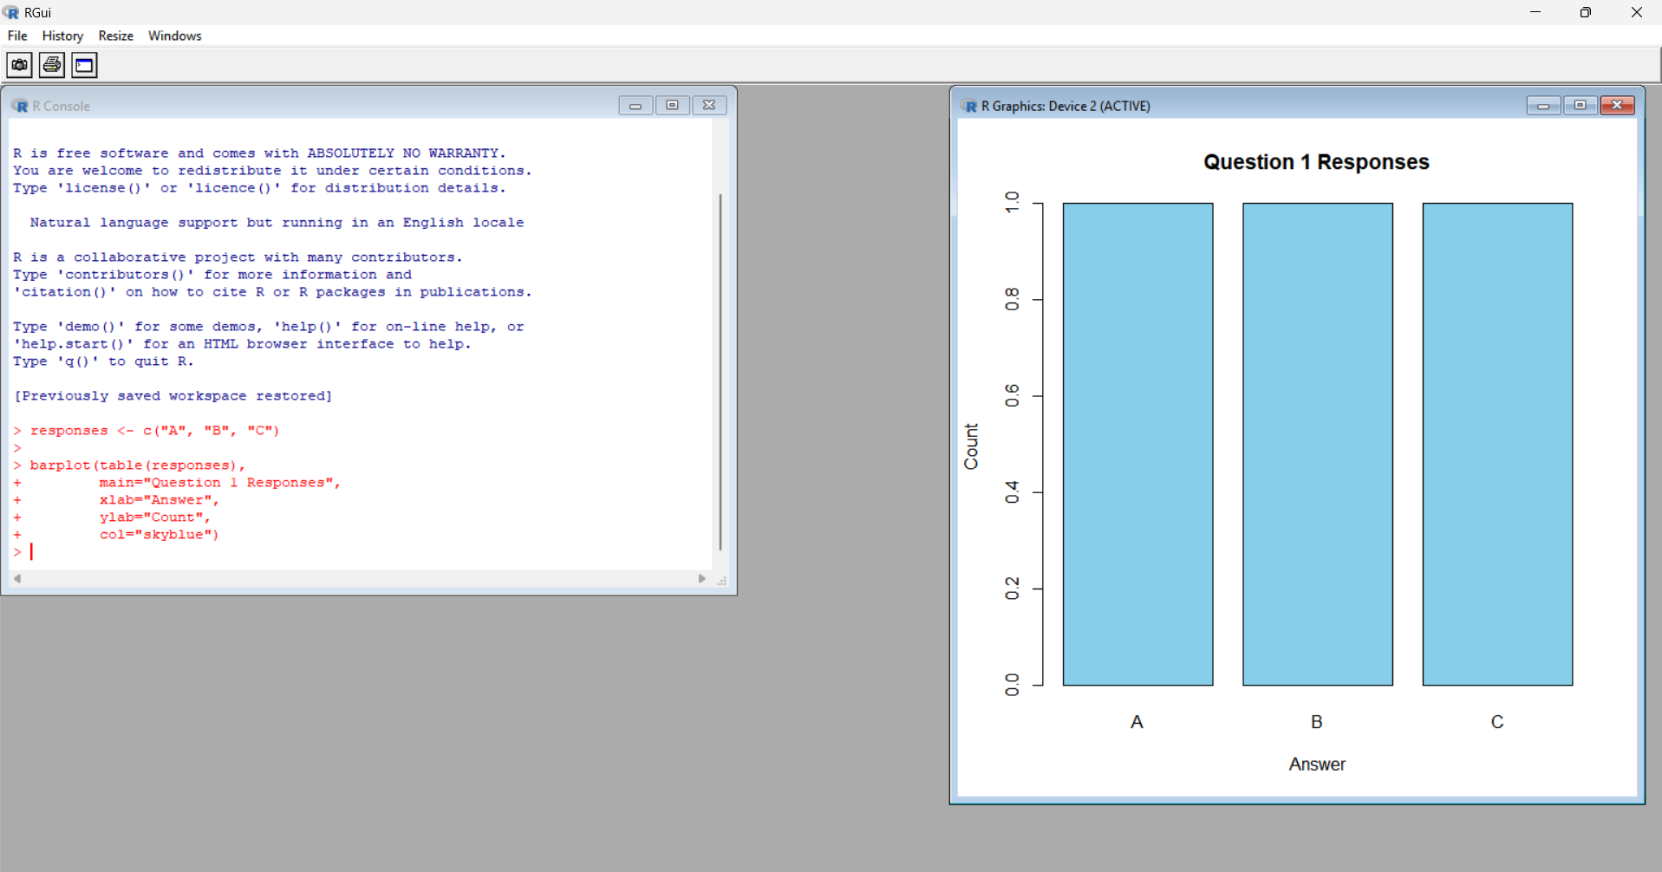
PROGRAM 2: STACKED BAR CHART OF ALL QUESTIONS
R Code
responses <- rbind(
Q1=c(1,1,1,0),
Q2=c(2,1,0,0),
Q3=c(0,1,1,1)
)
colnames(responses) <- c("A","B","C","D")
barplot(t(responses),
main="Responses by Question",
xlab="Question",
ylab="Count",
col=c("skyblue","orange",
"lightgreen","pink"),
legend.text=colnames(responses))
Observation: Question 2 has two A responses. Question 3 contains responses B, C, and D.
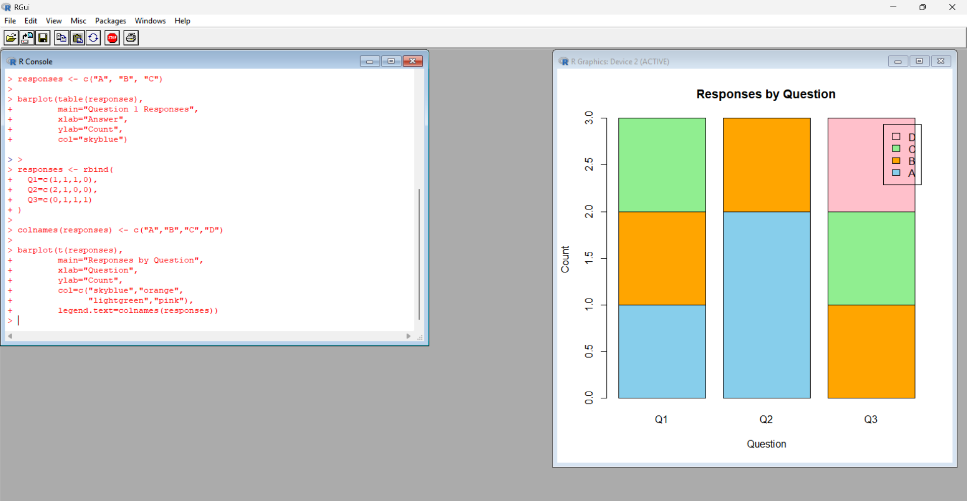
PROGRAM 3: DISPLAY SURVEY RESPONSE TABLE
R Code
survey <- data.frame(
Survey_ID=1:3,
Question_1=c("A","B","C"),
Question_2=c("B","A","A"),
Question_3=c("C","D","B")
)
print(survey)
Observation: The table displays the answers given by each survey participant.
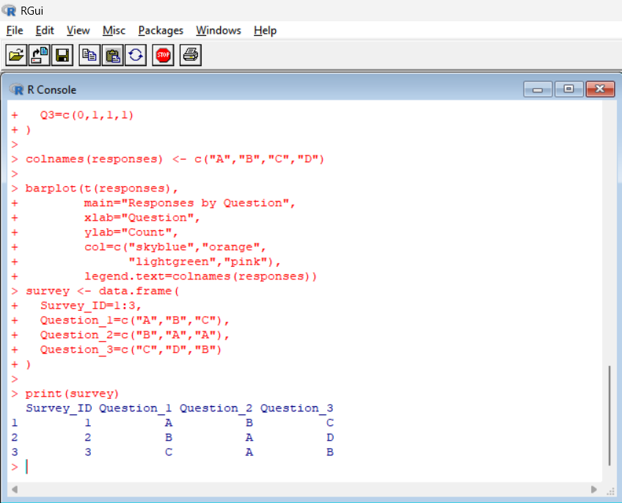
PROGRAM 4: CREATE A TABLEAU DASHBOARD
Procedure
- Save the dataset as Survey_Responses.xlsx.
- Open Tableau and connect to the Excel file.
- Create a bar chart for Question 1 responses.
- Create a stacked bar chart for responses across all questions.
- Add the survey response table.
- Combine the visualizations into one dashboard.
Observation: The dashboard helps compare survey response distributions.
PROCEDURE
- Open R or RStudio.
- Enter the dataset and execute the R programs.
- Observe the generated charts and table.
- Create the Tableau dashboard using the given procedure.
- Record the observations.
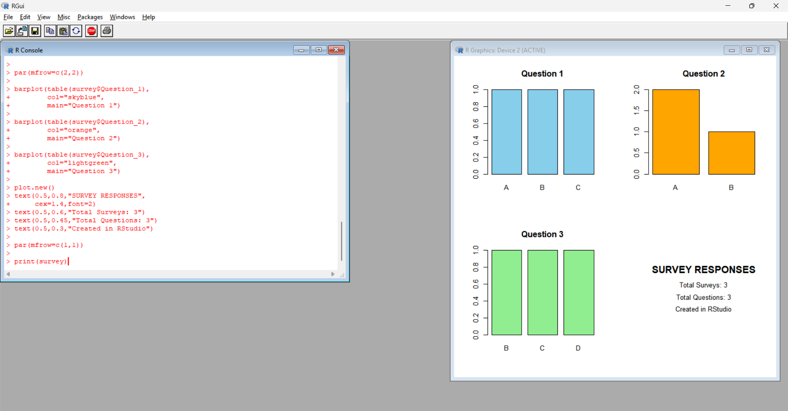
RESULT
Survey responses were analyzed using bar charts, a stacked bar chart, and a data table. A Tableau dashboard was outlined for comparing the responses.

